**Create a new React Application with the name “myfirstreact”, Run the application to print “welcome to the first session of React” as heading of that page.**

**App.js**

import React from 'react';

function App()

{

  return (

    <div>

      <h1>Welcome to the first session of React</h1>

    </div>

  );

}

export default App;

**Output**

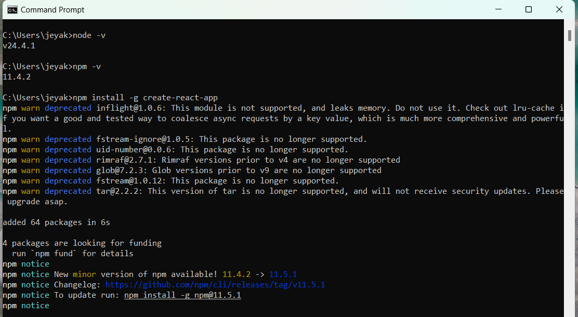

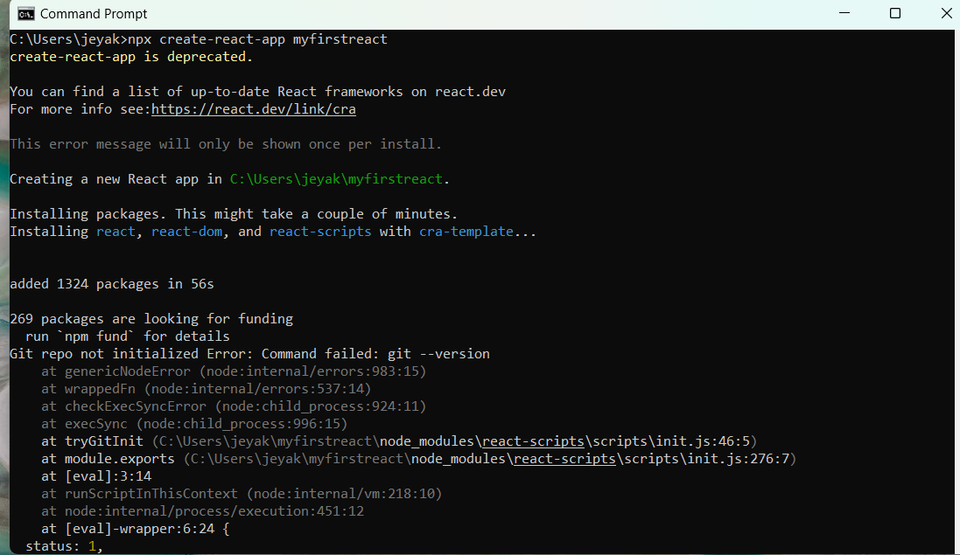

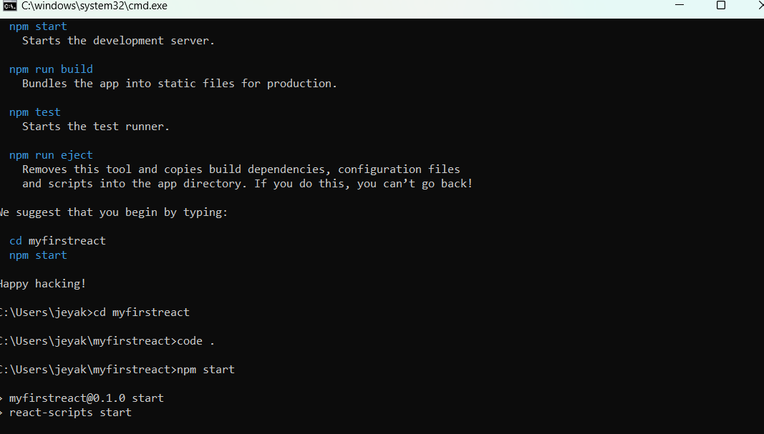

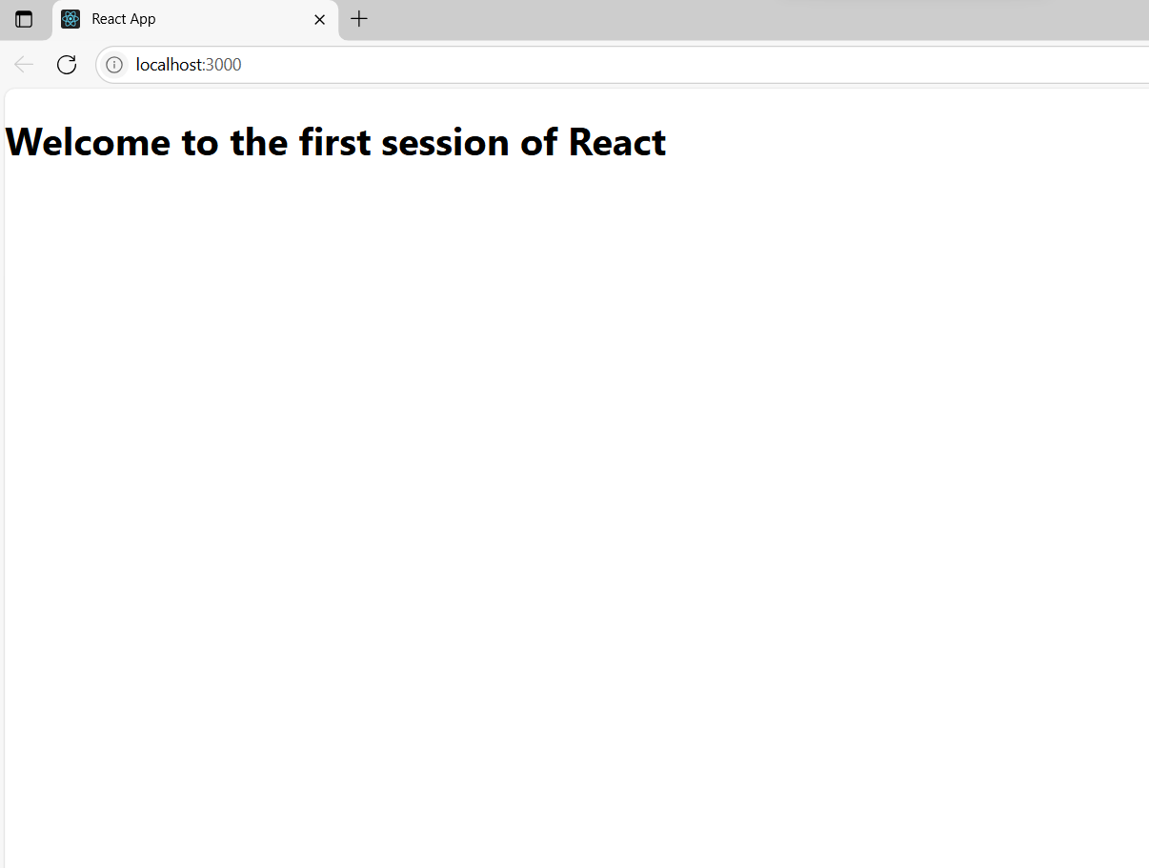

**Create a react app for Student Management Portal named StudentApp and create a component named Home which will display the Message “Welcome to the Home page of Student Management Portal”. Create another component named About and display the Message “Welcome to the About page of the Student Management Portal”. Create a third component named Contact and display the Message “Welcome to the Contact page of the Student Management Portal”. Call all the three components.**

**Home.js**

import React from 'react';

function Home() {

return (

<div>

<h2>Welcome to the Home page of Student Management Portal</h2>

</div>

);

}

export default Home;

**About.js**

import React from 'react';

function About() {

  return (

    <div>

      <h2>Welcome to the About page of the Student Management Portal</h2>

    </div>

  );

}

export default About;

**Contact.js**

import React from 'react';

function Contact() {

  return (

    <div>

      <h2>Welcome to the Contact page of the Student Management Portal</h2>

    </div>

  );

}

export default Contact;

**App.js**

import React from 'react';

import Home from './components/Home';

import About from './components/About';

import Contact from './components/Contact';

function App() {

  return (

    <div className="App">

      <h1>Student Management Portal</h1>

      <Home />

      <About />

      <Contact />

    </div>

  );

}

export default App;

**Output**

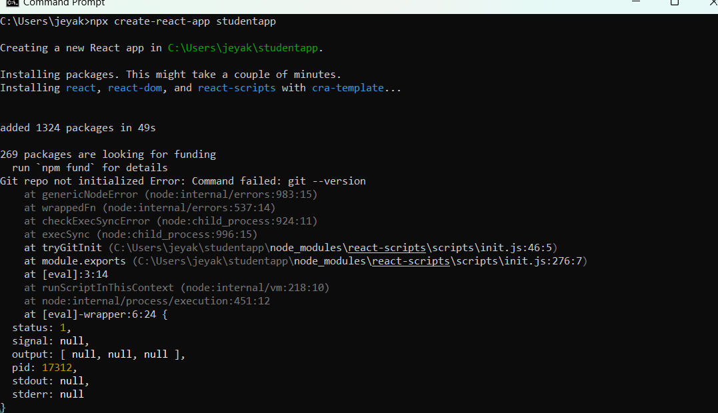

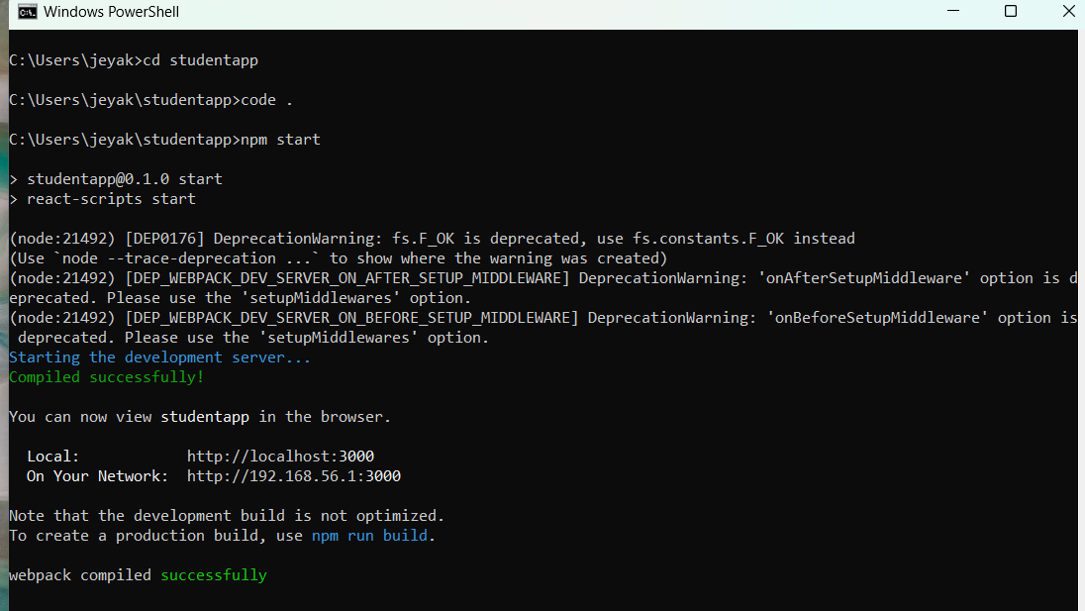

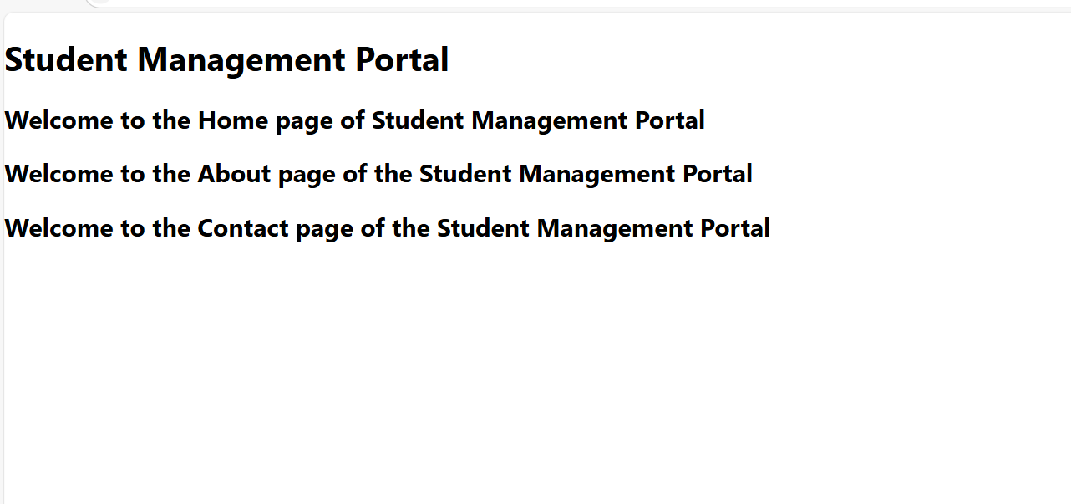

**Create a react app for Student Management Portal named scorecalculatorapp and create a function component named “CalculateScore” which will accept Name, School, Total and goal in order to calculate the average score of a student and display the same.**

**CalculateScore.js**

import React from 'react';

import '../StyleSheets/mystyle.css';

const percentToDecimal = (decimal) => {

  return (decimal.toFixed(2)) + "";

};

const calcScore = (total, goal) => {

  return percentToDecimal(total / goal);

};

export const CalculateScore = ({ Name, School, total, goal }) => (

  <div className="formatstyle">

    <h1><font color="brown">Student Details:</font></h1>

    <div className="Name">

      <b><span>Name: </span></b>

      <span>{Name}</span>

    </div>

    <div className="School">

      <b><span>School: </span></b>

      <span>{School}</span>

    </div>

    <div className="Total">

      <b><span>Total: </span></b>

      <span>{total}</span> Marks

    </div>

    <div className="Score">

      <b>Score:</b>

      <span>

        {calcScore(total, goal)}

      </span>

    </div>

  </div>

);

**mystyle.css**

.Name {

  font-weight: 300;

  color: blue;

}

.School {

  color: crimson;

}

.Total {

  color: darkmagenta;

}

.formatstyle {

  text-align: center;

  font-size: large;

  border: 2px solid #ccc;

  margin: 30px auto;

  padding: 20px;

  width: 60%;

  background-color: #f0f8ff;

  border-radius: 10px;

}

.Score {

  color: forestgreen;

}

**App.js**

import React from 'react';

import { CalculateScore } from './Components/CalculateScore';

function App() {

  return (

    <div>

      <CalculateScore

        Name={"Steeve"}

        School={"DNV Public School"}

        total={284}

        goal={3}

      />

    </div>

  );

}

export default App;

**Output**

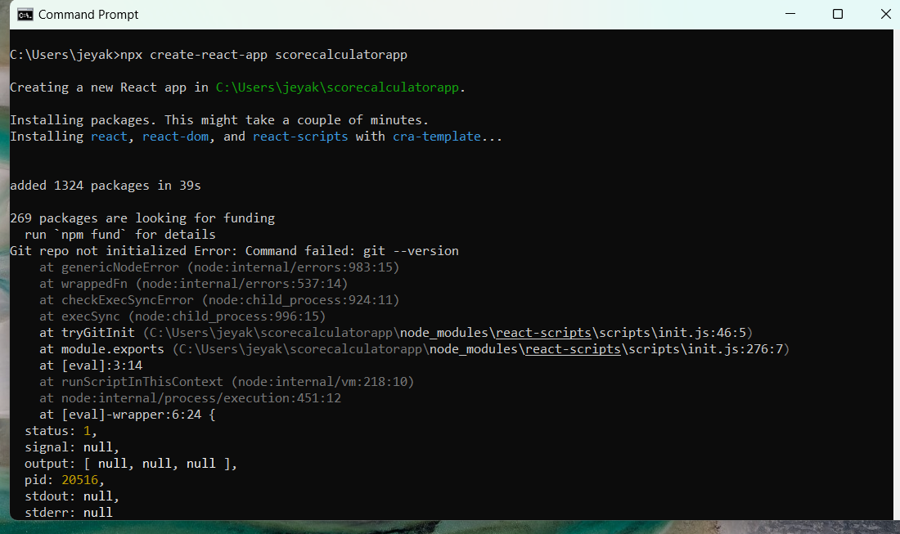

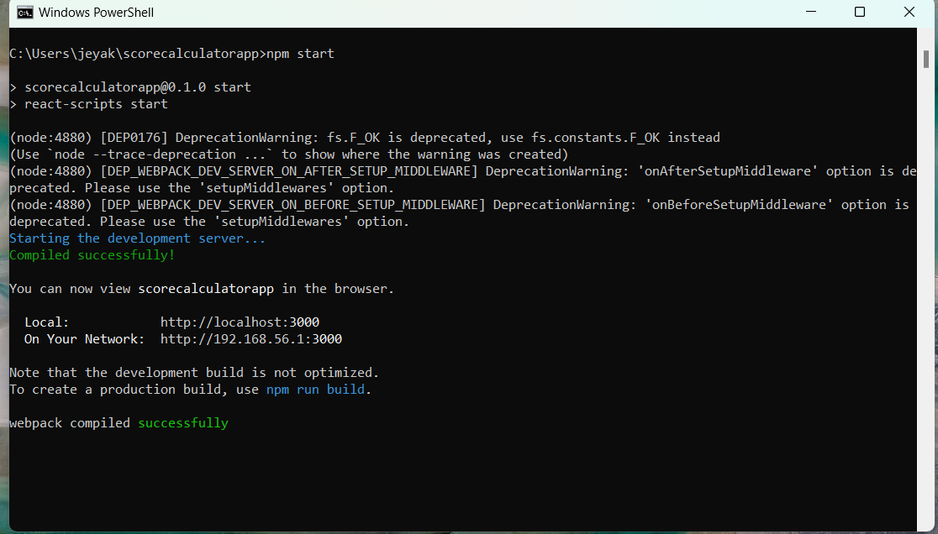



**Create a new react application using *create-react-app* tool with the name as “blogapp”**

**Post.js**

class Post {

  constructor(id, title, body) {

    this.id = id;

    this.title = title;

    this.body = body;

  }

}

export default Post;

**Posts.js**

import React from 'react';

import Post from './Post';

class Posts extends React.Component {

  constructor(props) {

    super(props);

    this.state = {

      posts: [],

      hasError: false,

      errorMessage: ''

    };

  }

  loadPosts = () => {

    fetch('https://jsonplaceholder.typicode.com/posts')

      .then(response => response.json())

      .then(data => {

        const postList = data.map(

          post => new Post(post.id, post.title, post.body)

        );

        this.setState({ posts: postList });

      })

      .catch(error => {

        this.setState({ hasError: true, errorMessage: error.message });

      });

  };

  componentDidMount() {

    this.loadPosts();

  }

  render() {

    if (this.state.hasError) {

      return <h2>Error occurred: {this.state.errorMessage}</h2>;

    }

    return (

      <div>

        <h1>Blog Posts</h1>

        {this.state.posts.map(post => (

          <div key={post.id}>

            <h2>{post.title}</h2>

            <p>{post.body}</p>

            <hr />

          </div>

        ))}

      </div>

    );

  }

}

export default Posts;

**App.js**

import React from 'react';

import Posts from './Posts';

function App() {

  return (

    <div className="App">

      <Posts />

    </div>

  );

}

export default App;

**Output**

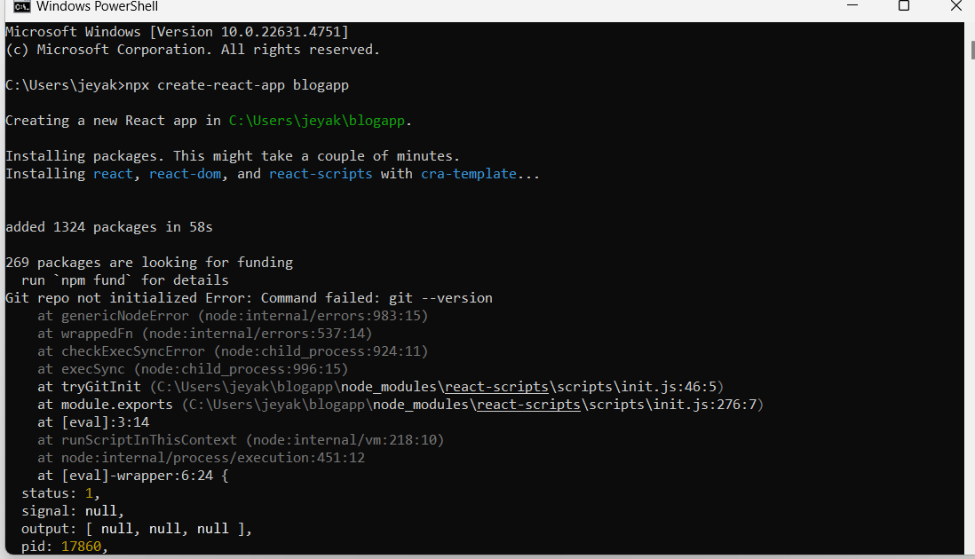

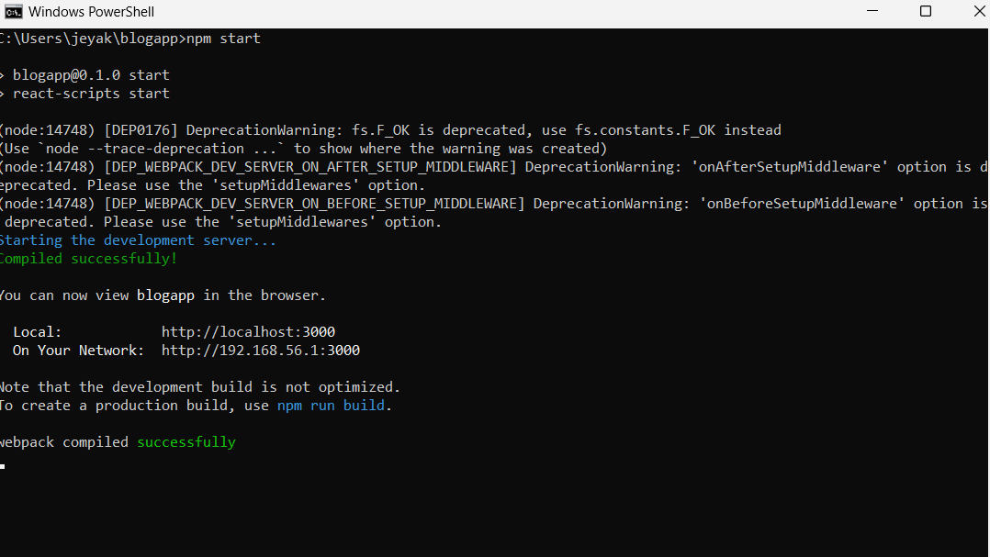

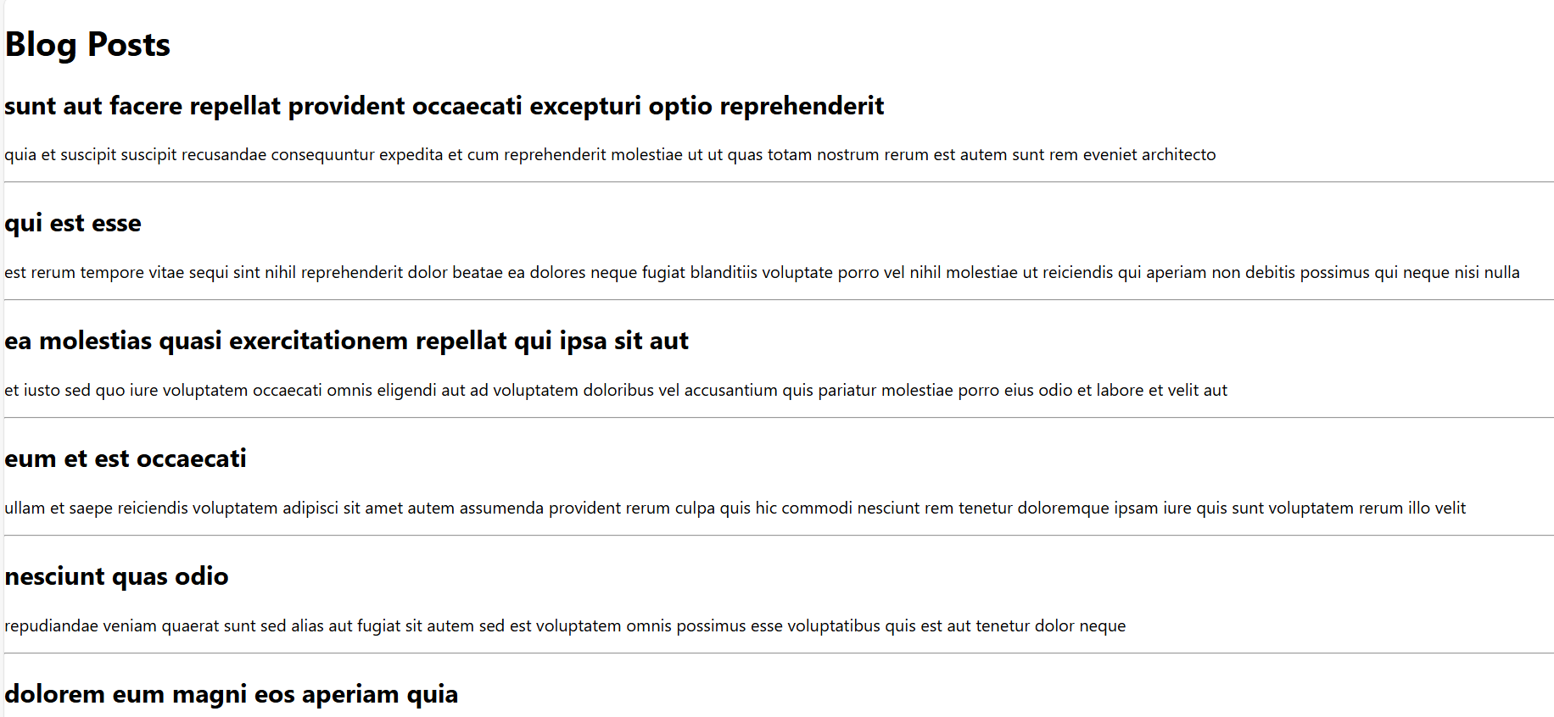

**My Academy team at Cognizant want to create a dashboard containing the details of ongoing and completed cohorts. A react application is created which displays the detail of the cohorts using react component. You are assigned the task of styling these react components.**

**Cohorts.js**

import React from 'react';

import '../Stylesheets/mystyle.css';

const cohortList = [

  {

    name: "INTADMDF10 - .NET FSD",

    startedOn: "22 Feb 2022",

    status: "Scheduled",

    coach: "Aarthma",

    trainer: "Jojo Jose"

  },

  {

    name: "ADME21JF014 - Java FSD",

    startedOn: "10 Sep 2021",

    status: "Ongoing",

    coach: "Apoorvi",

    trainer: "Elsa Smith"

  },

  {

    name: "CDBJZ21025 - Java FSD",

    startedOn: "21 Dec 2021",

    status: "Ongoing",

    coach: "Aarthma",

    trainer: "Jojo Doe"

  }

];

const Cohorts = () => {

  return (

    <div className="cohort-wrapper">

      <h2>Cohorts Details</h2>

      <div className="cohort-container">

        {cohortList.map((cohort, index) => (

          <div key={index} className="cohort-card">

            <h3

              className={

                cohort.status.toLowerCase() === 'ongoing'

                  ? 'ongoing-heading'

                  : 'default-heading'

              }

            >

              {cohort.name}

            </h3>

            <p><strong>Started On</strong><br />{cohort.startedOn}</p>

            <p><strong>Current Status</strong><br />{cohort.status}</p>

            <p><strong>Coach</strong><br />{cohort.coach}</p>

            <p><strong>Trainer</strong><br />{cohort.trainer}</p>

          </div>

        ))}

      </div>

    </div>

  );

};

export default Cohorts;

**mystyle.css**

.cohort-wrapper {

  padding: 20px;

  border: 1px solid #ccc;

  width: fit-content;

  margin: 20px;

}

.cohort-container {

  display: flex;

  gap: 20px;

}

.cohort-card {

  border: 1px solid lightgray;

  padding: 10px;

  width: 200px;

}

.ongoing-heading {

  color: green;

}

.default-heading {

  color: blue;

}

**App.js**

import React from 'react';

import Cohorts from './Components/Cohorts';

function App() {

  return (

    <div className="App">

      <Cohorts />

    </div>

  );

}

export default App;

**Output**

